TASK 02
#include <iostream>
using namespace std;

class Runner {
public:
string name;
int time;

Runner() {}
Runner(string n, int t) {
name = n;
time = t;
}

void input(int idx) {
cout << "Enter name and finish time for runner " << idx + 1 << ": ";
cin >> name >> time;
}
};

void merge(Runner arr[], int l, int m, int r) {
int i = l, j = m + 1, k = l;
Runner temp[10];
while(i <= m && j <= r) {
if(arr[i].time <= arr[j].time) {
temp[k++] = arr[i++];
} else {
temp[k++] = arr[j++];
}
}
while(i <= m) {
temp[k++] = arr[i++];
}
while(j <= r) {
temp[k++] = arr[j++];
}
for(int s = l; s <= r; s++) {
arr[s] = temp[s];
}
}

void mergesort(Runner arr[], int l, int r) {
if(l < r) {
int m = l + (r - l) / 2;
mergesort(arr, l, m);
mergesort(arr, m + 1, r);
merge(arr, l, m, r);
}
}

int main(){
const int n = 10;
Runner arr[n];
for(int i = 0; i < n; ++i) {
arr[i].input(i);
}

mergesort(arr, 0, n - 1);

cout << "\nTop 5 fastest runners:\n";
for(int i = 0; i < 5 && i < n; ++i) {
cout << i + 1 << ". " << arr[i].name << " - " << arr[i].time << " seconds\n";
}
}

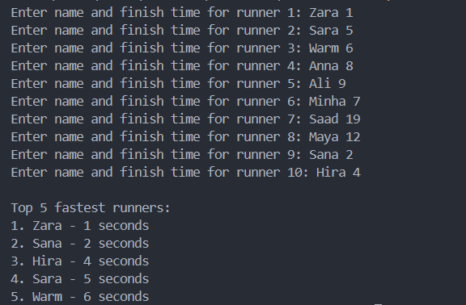

TASK 03
#include <iostream>
using namespace std;

class Products {
string name;
float price;
string description;
bool availability;

public:
Products(string n, float p, string d, bool a) : name(n), price(p), description(d), availability(a) {}

float getPrice() const { return price; }

void display() {
cout << "Product Name: " << name << endl;
cout << "Price: $" << price << endl;
cout << "Description: " << description << endl;
cout << "Availability: " << (availability ? "In Stock" : "Out of Stock") << endl;
}
};

void quickSort(Products arr[], int left, int right){
if (left >= right) return;

float pivot = arr[right].getPrice();
int i = left;

for (int j = left; j < right; j++) {
if (arr[j].getPrice() < pivot) {
swap(arr[i], arr[j]);
i++;
}
}
swap(arr[i], arr[right]);

quickSort(arr, left, i - 1);
quickSort(arr, i + 1, right);
}

int main() {
Products products[] = {
Products("Product 1", 10.99, "This is product 1", true),
Products("Product 2", 5.99, "This is product 2", true),
Products("Product 3", 2.99, "This is product 3", true),
};
int n = sizeof(products) / sizeof(products[0]);

cout << "Before sorting:\n";
for (int i = 0; i < n; i++) {
products[i].display();
cout << endl;
}

quickSort(products, 0, n - 1);

cout << "After sorting by price:\n";
for (int i = 0; i < n; i++) {
products[i].display();
cout << endl;
}

return 0;
}

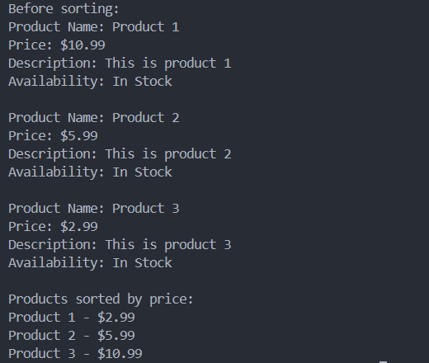
TASK 06
#include <iostream>
using namespace std;

#define MAX 1000

class Stack {
int top;

public:
int arr[MAX];
Stack() : top(-1) {}

bool push (int x) {
if (top >= MAX - 1) {
cout << "Stack Overflow" << endl;
return false;
} else {
arr[++top] = x;
return true;
}
}

int pop() {
if (top < 0) {
cout << "Stack Underflow" << endl;
return 0;
} else {
int x = arr[top--];
return x;
}
}

int peek() {
if (top < 0) {
cout << "Stack is Empty" << endl;
return 0;
} else {
int x = arr[top];
return x;
}
}

bool isEmpty() {
return (top < 0);
}
};

int main() {
Stack s;
s.push(10);
s.push(20);
s.push(30);
cout << s.pop() << " Popped from stack" << endl;
cout << "Top element is: " << s.peek() << endl;
cout << "Stack empty: " << (s.isEmpty() ? "Yes" : "No") << endl;
return 0;
}

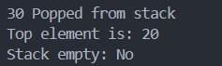
TASK 08
#include <iostream>
#include <string>
using namespace std;

#define MAX 1000

class Stack {
int top;

public:
int arr[MAX];
Stack() : top(-1) {}

bool push (int x) {
if (top >= MAX - 1) {
cout << "Stack Overflow" << endl;
return false;
} else {
arr[++top] = x;
return true;
}
}

int pop() {
if (top < 0) {
cout << "Stack Underflow" << endl;
return 0;
} else {
int x = arr[top--];
return x;
}
}

int peek() {
if (top < 0) {
cout << "Stack is Empty" << endl;
return 0;
} else {
int x = arr[top];
return x;
}
}

bool isEmpty() {
return (top < 0);
}
};

int precedence(char op) {
if (op == '+' || op == '-') return 1;
if (op == '*' || op == '/') return 2;
if (op == '^') return 3;
return -1;
}

string infixToPostfix(string infix) {
string postfix = "";
Stack s;

for (int i = 0; i < infix.length(); i++) {
char c = infix[i];

if ((c >= 'a' && c <= 'z') || (c >= 'A' && c <= 'Z')) {
postfix += c;
} else if (c == '(') {
s.push(c);
} else if (c == ')') {
while (!s.isEmpty() && s.peek() != '(') {
postfix += (char)s.pop();
}
if (!s.isEmpty() && s.peek() == '(') {
s.pop();
}
} else {
while (!s.isEmpty() && precedence(c) <= precedence(s.peek()) && s.peek() != '(') {
postfix += (char)s.pop();
}
s.push(c);
}
}
while (!s.isEmpty()) {
postfix += (char)s.pop();
}
return postfix;
}

int main() {
string expr = "(A+B/C*(D+C)-F)";
cout << "Infix: " << expr << endl;
cout << "Postfix: " << infixToPostfix(expr) << endl;
return 0;
}

